4. Parkside pre-school Forest School Policies and Procedures

Policy statement

Parkside Forest School aims to use the agreed forest area (Deanary Gardens, Hadleigh) which has been designated as a Forest School site by HEAT and St. Mary's Primary School, though we are not limited to this Forest School site and any other site used by Parkside will be fully risk assessed to ensure fit for purpose.

When running Forest School sessions Parkside will adhere to the legal EYFS framework for ratios, it is the duty of the Forest School leaders to ensure that these are adhered to safely at all times.

We intend to offer the children an insight into the Forest School ethos and enrich learning and development through nature and exploring in the natural outdoors environment. Forest School is a holistic approach to learning, incorporating children’s individuality and develops their skills for lifelong learning. We aim to offer children opportunities to succeed, develop and build new skills through physical and holistic activities within the woodland site. We are highly trained to understand all areas of children's development, and well being and seek to enrich their lives through new experiences.

Staff leading and assisting with the Forest School provision will understand and implement the key principles of Forest School, understand all policies and procedures and consider the risk assessments of all running sessions. Forest School is underpinned by 6 core principles as defined by the Forest School Association, these are:

1. Forest School is a long-term process of regular sessions, rather than one-off or infrequent visits. The cycle of planning, observation, adaptation and review links each session.

2. Forest School takes place in a natural or woodland environment to support the development of a lifelong relationship between the learner and the natural world.

3. Forest School aims to promote the holistic development of all involved, fostering resilient, confident, independent and creative learners.

4. Forest School offers learners the opportunity to take supported risks appropriate to the environment and to themselves.

5. Forest School is run by qualified Forest School practitioners, who continuously maintain and develop their professional practice.

6. Forest School uses a range of learner-centred processes to create a community for being, development and learning.

Alongside our Forest School policy we will also adhere to the following policies, ensuring that health, safety and safeguarding is paramount.

Health & safety
First Aid
Safeguarding
Missing Child
Confidentiality
Risk Assessment
Food hygiene with outdoor cooking
Behaviour
Equality
Prevent
Accident & Emergency
Manual handling
SEND
GDPR
Employment
Staffing & ratios
Online safety

Our Forest School sessions will only be delivered by our Forest School Leaders (level 3) and will be assisted by other pre-school staff if required.
Our Forest School leaders are: Mica Robinson and Rhiannon Grimsey

Roles and Responsibilities - Forest School Leader will have the overall responsibility for:
• Risk assessments for an overall site check, daily assessment and continuous safety monitoring, taking into consideration the weather. Please see risk assessments.
• Planning for sessions, differentiation for individual children’s needs.
• Ensure rules are followed whilst on Forest School site and respect for the Deanary Gardens, Father Jo and his family.
• Ensuring necessary equipment is taken into woodland.
• Administration of first aid and checking first aid kit.
• Supervision of fire use - following the procedures set out below.
• Supervision of tools use, cleaning and storing – following the procedures set out below.
• Organising emergency procedures.
• Ensure the woodland is left as it was found after every session.
• Be mindful of the ecological impact and biodiversity planning.

Staff, students or volunteers assisting will be responsible to the Forest School leaders and will monitor safety and support in the smooth running of the Forest School sessions.

Insurance
All of Parkside Forest School sessions will be covered by full insurance through The Early Years Alliance. Our policy no. Is: RTT209838

Weather monitoring

‘there is no such thing as bad weather, only inappropriate clothing’
When attending Forest School sessions parents and carers are advised to dress children warmly and wear waterproofs if necessary. Parkside do have spare clothing and waterproofs which can be used if required. There are some occasions where it may not be safe or practical to carry out a planned session due to extreme weather.
Circumstances when a Forest School session WILL NOT run are as follows:
• In the case of high winds of 25mph or more determined by the met office online.
• If a thunderstorm occurs the session will be cancelled immediately.
• In the case of extreme temperature determined by a met office amber weather warning
• In the case of extreme cold of below ‘0’ a session will be cancelled if it is near to this we will ensure children are appropriately dressed, sessions will be made shorter and activities will be planned to ensure children are kept moving.

It is the responsibility of the Forest School leaders to plan and assess the weather conditions before and during each Forest School sessions, as per the risk assessments.

Environmental

Parkside aim to educate children, staff and volunteers about the ecological impact of the woodland areas and we aim to encourage minimal impact of us using the site. We will discover and find out about the different animals and plants that live in a woodland environment and respect that the woodland is their place first. We will teach respect for the natural environment and encourage observation of wildlife, taking into consideration the seasons and life cycles. Parkside will never leave litter on the Forest School site and will teach children to assist in clearing away any materials or litter before we depart, We will always leave the Forest School site as we found it with as little impact as possible.
We will work together and take responsibility as a group network with other users of the site including HEAT and St. Mary's Primary School.

Parkside constantly monitors the environmental impact on the Forest School site, and will record and assess during different seasons and weather changes. We will always monitor the use of fire ethically and responsibly (as per fire risk assessment) and we will always use a fire fit when lighting fire to minimise the disturbance to the grounds. We aim to use as many biodegradable, natural and sustainable resources as possible for activities.

Parkside will seek to protect, maintain and improve the biodiversity of the Forest School site and will educate the children attending Forest School, we will continually assess and update our biodiversity action plan and will make changes if required to ensure that we have as minimal ecological impact as possible.

​We respect the land is owned by The Parish Council and is maintained effectively.

Tool use

Before using tools all staff or volunteers assisting will be shown fully how to use and will adhere to Parkside's code of conduct (practical skills) in regards to rules, safety and maintenance.
- Children will be shown and monitored closely when using tools
- Staff will adhere to tool use risk assessment.
- Relevant PPE will be worn at all times.
- Tools will be counted in and out and checked against an inventory.
- Tools will be stored safely and kept out of the reach of children.
- Tools will be maintained to pro long their life and ensure kept rust free

Fire use
- A Forest School Leader must always be present when a fire is lit and it is their responsibility to ensure it is never left unattended.
- There must always be water available to extinguish the fire.
- There will be a designated area and fire will only be lit in the designated area
- Children will be taught the fire pit rules and procedures and we will also teach fire safety whilst adhering to our code of conduct for fire safety.
- Adults will role model fire safety, for example will not walk across the inner fire circle.
- A fire box should be placed next to the fire circle, containing fire gloves, first aid kit, fire blanket and there should always be a bucket of water placed closed by.
Welfare
We will ensure that all children are suitably clothed to attend forest school; parents will be advised to send their children in weather appropriate clothing but have been advised that long trousers, long sleeve tops and closed toe shoes are to be worn in all weathers due to the stinging nettles on sight. This will be shared with parents as an example of appropriate clothing.
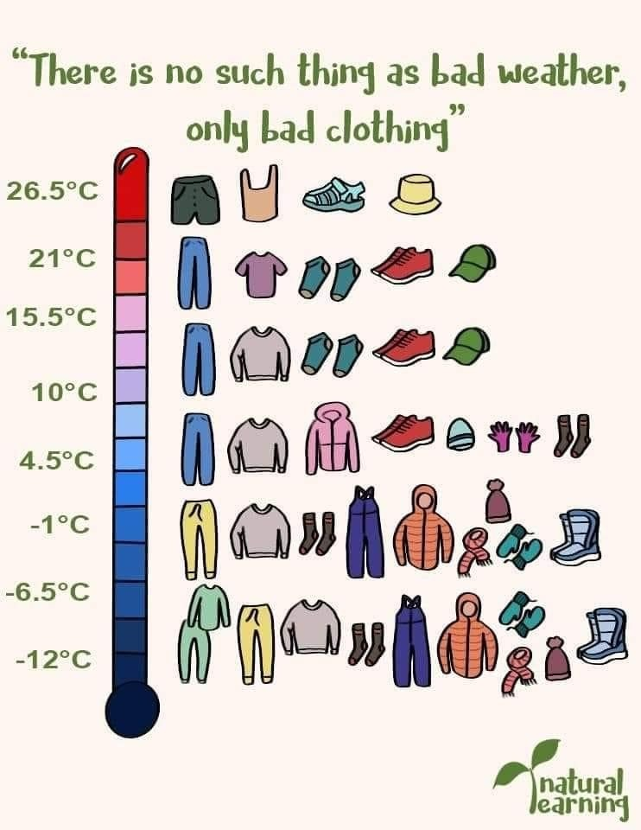

Pre-school have puddle suits that are to be worn in colder weather, if these are not worn, high vis jackets are to be worn at all times as a form of safety identification.

PPE- Staff are to wear appropriate PPE in all relevant scenarios, this includes tool use, fire use and also during personal hygiene care for the children. Our first aid kit will be stocked with gloves and aprons for use in personal hygiene care and also for first aid use.
Toileting- children are encouraged to have a “bush wee”, they are allowed to find a space to urinate. We will talk to the children about ensuring there is nothing dangerous or that may hurt where they go. Only DBS checked members of staff are to accompany children to the toilet. If a child does not feel comfortable going to the toilet in the forest we do have a potty that they can use. This is to be disposed of in an appropriate way and sanitised after use. A hand wash station is available for the children to use, this will be encouraged to use after activities such as bug hunting.

References
Forest School Association

This policy was adopted by | Hadleigh Parkside pre-school
On (date) | March 2024
To be reviewed | March 2025
Signed
Name of signatory | (1) Mica Robinson (deputy manager & FS Leader)
 | (2) Rhiannon Grimsey (room leader & FS Leader)

